

**COLLEGE OF COMPU TING AND INFORMATION SCIENCES**

A SCHEDULING MOBILE APPLICATION

A CASE STUDY OF MAKERERE UNIVERSITY HOSPITAL

By

CS17-03

**DEPARTMENT OF COMPUTER SCIENCE**

**SCHOOL OF COMPUTING AND INFORMATICS TECHNOLOGY**

A Project Report Submitted to the School of Computing and Informatics Technology

For the Study Leading to a Project Report in Partial Fulfillment of the

Requirements for the Award of the Degree of Bachelor of Science in Computer Science

Of Makerere University

Supervisor

Mr. Lule Emmanuel

School of Computing and Informatics Technology, Makerere University

[lule.emmanuel@cis.mak.ac.ug], +256-752-958-121

[June, 2017]

# Declaration

We, group CS 17-03, hereby declare that the work presented is original and has never been submitted for an award to any university or institution of higher learning. We can confirm that where we have done consultations either from published material or the works of others, it has been attributed in this report.

**GROUP MEMBERSHIP**

|  |  |  |  |
| --- | --- | --- | --- |
| No | Names | Registration Number | Signature |
| 1 | DDAMULIRA ANDREW WOMERAKA | 14/U/230 |  |
| 2 | KUZANYA JOHN BOSCO | 14/U/8343/PS |  |
| 3 | TAGUYISIZA YAHAYA | 14/U/15104/PS |  |
| 4 | SEMUKO FAISAL | 14/U/14593/PS |  |

# Approval

This project report titled Scheduling Mobile Application has been submitted for examination with my approval as the supervisor of group CS 17-03.

Mr. Lule Emmanuel

Department of Computer Science

School of Computing and Informatics Technology

College of Computing and Information Sciences,

Makerere University

Signature ……………….……………………….. Date………………………

Supervisor

# Dedication

We dedicate this project to the Almighty God who has given us life and strength throughout this

period up to date.

And lastly to our dear parents and guardians, for your tireless efforts for giving us good

education and your continuous struggle to pay our tuition, we thank you and dedicate all this

hard work to you. Thank you very much for your love and support.

# 

# Acknowledgement

The success of this project, apart from the authors’ efforts, largely depends on the

encouragement and contributions of many. A very huge thanks to Mr. Lule Emmanuel for your

guidance, support, help and continuous availability will never be forgotten. You have

instilled in us a great confidence with the motivational speeches you gave us and you have

earned a special place in our hearts for all the support you have thrown our way. Without you

none of this would have been possible and this project would have never been completed.

To our dear lecturers, we are forever indebted to you for teaching us everything

we know about computers and computer science. Thank you for providing us with knowledge which will help us in future and making us realize how valuable we are to the future

development of our country and the computing industry at large.

To our friends and fellow “computer scientists”, we thank you a greatly for

Puttin up the various application tests and helping us in collecting requirements. We shall always thank you for your help.

Lastly, to the Lord God Almighty, Glory is unto your name. Thank you for keeping us safe

throughout this period and keeping us all healthy and lively. We give you all the praise.

# Abstract

Makerere university hospital has been providing services to students of makerere universit and local people for the past thity seven years. Due to to the increase in intakes at makerere university, reliable service delivery to students has detoriated since many students visit the hospital and the available staff cannot cater for the increased population

Information management in many hospitals is both paper-based and traditional. It also

involves using some automated applications such as Microsoft office package to write up Medical Personnel schedules, patient slips, etc. Despite this automation, nearly all of the hospital

activities, processes and the tools used are for the paper-based approach. To solve this

problem, we proposed the development of the SMA.

The developed Scheduling Mobile Application (SMA) can support the the different hospital activities with ease and also also provide mobules to be used in the day-to-day activities and sharing of information at the hospital

We deveped the project basing on collected requirements and specifications

obtained by using techniques such as interviews, document reviewing and questionnares. The case study used in

the development of the application was Makerere University Hospital (MUH). The application was

designed to support the major processes  at the hospital which include student making appointments using the application and also registering them. The medical personnel are registered by the administrator and they can be able to view, accpt and reject students appointment requests.  The design of the system was done using a context diagram, entity relatinship Diagram, etcwhich were

constructed using Microsoft Visio . The system was developed using

technologies like Java, MySQL, Java script and it runs on android studio, a smart phone and on a desktop.

The adoption of this system and application would be valuable to MUH since such a system can help handle the

ever increasing volumes of  students at the university and information about the different activities that take place at the hospital. Additional functionalities like that notification for appointment approval are also working that enable efficient informaton delivery.

# Table of contents

Contents

Declaration 2

Approval 3

Dedication 4

Acknowledgement 5

Abstract 6

Table of contents 7

List of figures 9

List of tables 10

Abbreviations 11

MUH Makerere University Hospital 11

SMA Scheduling Mobile Application 11

DFD Data Flow Diagram 11

ERD Entity Relationship Diagram 11

CHAPTER 1 12

1.0 Introduction 12

1.1 Background 12

1.2 Problem Statement 13

1.3 Objectives 13

1.4 Scope 13

1.5 Significance 14

CHAPTER 2 15

2.0 Literature Review 15

2.1 Definitions 15

2.2 Current system used at the hospital 15

2.3 Existing systems 16

2.4 PROPOSED SYSTEM 18

2.5 Conclusion 19

Chapter 3 20

3.0 Methodology 20

3.1 Introduction 20

3.2 Requirements gathering 20

3.3 System design 21

3.4 Implementation 21

3.5 Testing and validation 21

CHAPTER FOUR 22

4.0 System analysis and design 22

4.1 Introduction 22

4.2 System study and analysis 22

4.2.1 Existing system 22

4.2.2 Weaknesses of the system 22

4.3 System Analysis 22

4.3.1 System requirements 23

4.4 SYSTEM DESIGN 24

4.4.1 Process modeling 24

4.4.2 Context diagram for the scheduling mobile application 24

4.4.3 Architecture design of the system 27

4.4.4 Use case diagram 28

4.5 DATA MODELLING 31

4.5.1 Conceptual data model 31

4.5.2 Modeling relationships between entities 31

4.5.3 Entity relationship diagram for our developed Scheduling Mobile Application 33

4.6 Physical design 33

CHAPTER 5 35

5.0 PRESENTATIONS AND FINDINGS 35

5.1 INTRODUCTION 35

5.2 LITERATURE REVIEW RESULTS 35

5.3 RESULTS OBTAINED FROM INTERVIEWS AND QUSETIONNAIRE 35

5.4 OBSERVATION RESULTS 36

5.5 DATA ANALYSIS RESULTS 36

5.6 IMPLEMENTATION RESULTS 37

5.7 SYSTEM FUNCTIONALITY 37

CHAPTER SIX 42

6.0 INTRODUCTION 43

6.1 CONCLUSION 43

6.3 LIMITATIONS 44

6.4 Recommendations 45

References 0

APPENDICES 1

INTERVIEW 1

QUESTIONNAIRE 3

OBSERVATION FORM 5

WORK PLAN FOR OUR PROJECT 6

BUDGET FOR OUR PROJECT 7

List of figures

Figure 1 showing SMA`s context Diagram 24

Figure 2 showing a data flow diagram for SMA 25

Figure 3 showing the architecture design of the system 27

Figure 4 showing the use case diagram for SMA 28

Figure 5 showing the administrator-student relationship 31

Figure 6 showing the medical personnel-student relationship 31

Figure 7 showing the administrator-medical relationship 32

Figure 8 showing the student-appointment relationship 32

Figure 9 showing the medical personnel-appointment relationship 32

Figure 10 showing the ERD for SMA 33

Figure 11 showing the home page for the SMA 38

Figure 12 showing the students` registration page 38

Figure 13 showing the students` registration page 38

Figure 14 showing the login page for students 39

Figure 15 showing the login page for a medical personnel 39

Figure 16 showing the services page 40

Figure 17 showing the appointment page where a student is choosing the time for the appointment 41

Figure 18 showing the appointment page where a student is choosing the date for the appointment 42

Figure 19 showing the page where the medical personnel chooses the time when he or she is available 42

# List of tables

Table 1 showing comparisons between the existing systems and the SMA 19

Table 2showing external entities of the DFD 26

Table 3 showing the processes of the DFD 26

Table 4 showing the data stores in the DFD 27

Table 5 showing description of symbols in the use case diagram 30

Table 6 showing the entities, descriptions and attributes of the ERD for SMA 31

Table 7 showing the description of the administrator entity 33

Table 8 showing the description of the medical personnel entity 34

Table 9 showing the description of the appointment entity 34

Table 10 showing the description of the student entity 34

# 

# Abbreviations

# MUH Makerere University Hospital

# SMA Scheduling Mobile Application

# DFD Data Flow Diagram

# ERD Entity Relationship Diagram

# VAR Veteran appointment request

# CHAPTER 1

**1.0 Introduction**

**1.1 Background**

Uganda’s health system was one of the best in the region by the 1960, it got worse in the 1970 during the military turmoil and civil strife. According to international health indicators, healthcare in Uganda is becoming more accessible and robustly public donor-private interlinked sector. (Mukasa, 2017) Following this trend along came Makerere University Hospital which is fully owned by the University. The hospital is located on Makerere Hill, off of Gaddafi Road, in [Kampala Central Division](https://en.wikipedia.org/wiki/Kampala_Central_Division), about 2 kilometers (1 mile), southwest of [Mulago National Referral Hospital](https://en.wikipedia.org/wiki/Mulago_National_Referral_Hospital). (wikipedia, 2016) Before 1972, the university maintained a health post known as [Makerere University](https://ugandaradionetwork.com/story/the-state-of-makerere-university-hospital) Students Health Service or Sick Bay at the current [Makerere University](https://ugandaradionetwork.com/story/the-state-of-makerere-university-hospital) Police Post.  In 1972, when Idi Amin expelled Asians, the university acquired the premises formerly known as [Nile Nursing Home](https://ugandaradionetwork.com/story/the-state-of-makerere-university-hospital). The university Sick Bay relocated to the new premises. On 16 February 1978, President Idi Amin visited the Sick Bay and elevated it to a Hospital status. (Ndyabahika, 2016)

The [Hospital](http://www.hospital.mak.ac.ug/) comprises of various units which render different services to the University Community.  It has medical units which are available to staff, both senior and junior, and to students. The [Hospital](http://www.hospital.mak.ac.ug/) has a 32 bed in-patient ward and admissions to the ward are exclusively for students only.  However, the [Hospital](http://www.hospital.mak.ac.ug/) Administration is trying in every ways possible to improve on the services and aspects of the [Hospital](http://www.hospital.mak.ac.ug/) so as to provide wider and better services to the University Community. (MakerereUniversity, 2017)

Makerere University hospital has expanded over the years due to the increased number of students admitted by the University. This has opened its doors and made it gain popularity to the public though still operating under the old name Makerere University Hospital.

The hospital uses manual registration to capture student records and this has led to delay in the registration process since the population of Makerere University is large which results to high physical costs to be incurred in buying material like papers. Also data management is expensive since it’s hard the manual registration process also leads to a poor mechanism in data management by making it hard for the user to delete, editing etc.

Since the population of Makerere University is so big, when students go for treatment or inquiries, the hospital gets over crowded which leads to some students missing out on treatment when the working hours are exceeded.

Our system will be able to solve the problems stated above in the following ways;

It will be able to register students online saving the time spent in the queues since its accessible anywhere and also saving material used during the registration process. The system will also provide an interface for students to have appointments with the different medical staff through booking to make sure that they get hospital services conveniently without wasting time in queues.

**1.2 Problem Statement**

Overcrowding has become a major problem at Makerere university hospital due to an increase in the number of students at Makerere University. This has caused delays in queues while students are waiting for treatment, counseling and registering with the hospital. Students have been reluctant to register with the hospital on time due to fear of making long lines while waiting for registration which makes them register at the last hour in their final years hence students are fined for late registration. Some students have diverted from the hospital and are now getting treatment from nearby clinics due to fear of making long queues most especially when they seriously sick hence poor medical service utilization by students.

**1.3 Objectives**

**Main Objective**

To develop an application that will enable Makerere university students register and request for appointments with the different medical personnel of different services at University with convenience in order to solve student’s congestion at the hospital.

**Specific Objectives**

The specific objectives of our system are:

1. To collect requirements needed to build the scheduling mobile application.
2. To analyze the requirements collected to build the scheduling mobile application.
3. To design application modules that will support requesting for appointments and registration of Makerere university students.
4. To implement the mobile application of the design mentioned in (2) above.
5. To test and validate the scheduling mobile application.

**1.4 Scope**

In this research, Makerere University hospital will be used as the case study. Medical staff depending on their roles in the hospital and students will be selected as a sample and interviewed in order to gather the necessary information that will lead to the success of the project.

Our research will majorly concentrate on providing an interface for students to request for appointments with Makerere university hospital staff of different specialties hence getting services effectively and conveniently without any delays.

It will also provide an interface for online registration of Makerere university students hence eliminating the paper based registration system that is used in the registration of students which is characterized with delayed access, hard to update and retrieval of information, depreciation of records in terms of wear and tear.

It will also help to overcome the problem of overcrowding at the hospital by the students.

**1.5 Significance**

The application will be able to provide a mechanism for students to request for appointments with different medical staff of different specialties who will set the time and date to meet all students who request for appointments hence providing equal chances for all students to access medical services at the hospital.

Students will be able to register with the hospital anywhere and anytime hence saving time spent in queues which will enable students to register as fast as possible.

This will generally overcome the problem of overcrowding of students at the hospital with the desire of accessing medical services since only students who have confirmed appointments with the different medical personnel will have to go to the hospital.

# CHAPTER 2

**2.0 Literature Review**

**Introduction**

The scheduling mobile application is an android supported mobile application that enables students of the Makerere University to do their registration with the hospital online and also make appointments depending on the doctors’ work and personal schedule for a particular day for all services provided at the hospital in that a student is allocated the exact time to see the medical attendant with convenience thereby solving the problem of congestion at the hospital.

**2.1 Definitions**

**Scheduling**

Scheduling is the process of arranging, controlling and optimizing work and workloads in a production process or manufacturing process. (wikipedia, 2017)

**Mobile application**

A mobile app is a software application developed specifically for use on small, wireless computing devices, such as [smartphones](http://searchmobilecomputing.techtarget.com/definition/smartphone) and [tablets](http://searchmobilecomputing.techtarget.com/definition/tablet-PC), rather than desktop or laptop computers. (Margaret, 2013)

**Scheduling mobile application**

This is a mobile application designed to help students to make appointments with Makerere university hospital medical staff of different specialties such that each student has an equal chance of receiving medical services and also register online with Makerere university hospital.

**2.2 Current system used at the hospital**

The University hospital currently uses a manual system for student registration with it where a student is required to physically go to the hospital with his or her admission form in order to be registered and further more appointments between the students and the medical staff is not supported with the current system.

This system faces the problems stated below.

Students spend relatively too much time in lines when they go to the hospital to be registered.

The nature of the system being manual, it becomes very difficult to edit data entered therefore mistakes in data may prevail in the hospital books.

The system is not convenient in a way that a student can’t register at his or her time of wish.

The current system becomes costly for students in situations when a student misses registration at a particular day and has to keep coming back at the hospital for the same purpose.

Due to the absentia of an appointment mechanism between medical staff and students, it becomes hard for a student to see a doctor on time due to overcrowding thereby leading to relatively long lines (queues) to be made.

**2.3 Existing systems**

**VETERAN APPOINTMENT REQUEST (VAR)**

 VAR makes it possible for Veterans to directly schedule primary care appointments and request assistance in booking both primary care and mental health appointments at the VA facilities where they receive care. In addition to scheduling appointments, Veterans can use VAR to track appointment details and the status of requests, send messages about requested appointments, receive notifications and cancel appointments. (U.S.DepartmentofVeteransAffairs, 2017)

**Benefits of the Veteran appointment request**

* You can cancel an appointment if you are unable to make it to that appointment
* See details for all pending, confirmed and upcoming appointments (both those requested through the app or through a VA scheduler), including date, time, clinic, care team and reason for visit

**Weaknesses of the system**

* It sends email notifications about appointment updates yet people rarely read their emails on a regular basis

**A WEB BASED HOSPITAL SERVICE SYSTEM**

The project is to design a website for the hospital to enable health providers and patients communicate more effectively through the transfer of health information and services between different locations. (Jackie, 2006)

**Benefits of the Web based hospital service system**

* To enable health providers and patients communicate more effectively.
* Transfer of health information and services between different locations.
* Enables access of health services by patients in different places thus improvement of health standards.
* Enables timely web response to users inquiries.

**Weakness of the system**

* The application only looks at transfer of health information and services between different locations for patients and health providers without looking at the availability of the service in question at a particular place.

**APPOINTMENT PRO**

Appointment pro is one of the most Installed scheduling systems in in hospitals in United States and other parts of the world. Appointment pro is installed in more than 4500 hospitals like: Hayes green beach hospital, Living medical center, Fairlawn rehabilitation hospital among others. (Spectrosoft, 2010)

**Benefits of the appointment pro application**

* The application has the ability to manage data.
* The application has a quick start up making it indispensable to the facilities it’s implementing.

**Weaknesses of appointment pro**

The patient cannot cancel an appointment.

**NEUMD SCHEDULING SYSTEM**

NeuMD Medical Scheduling is an easy-to-use Appointments module that can handle multi-physician, multi-day, or multi office schedules. “It can create new patients, schedule recurring appointments and manage co-pays in just a few clicks. Track patient flow with a time-stamped record arrival, check-in, visit departure time. The automated telephone appointment reminder service helps reduce no-shows by up to 30 percent”. (Neusofttechonologies, 2011)

**Benefits of NeuMD scheduling system**

* NeuMD offers cloud-based deployment option that can be easily customized in the way you want.
* NeuMD offers 12 hours of one-on-one coach training for new clients.
* The customer support of this practice management solution offers phone support.

**Weaknesses of** **NeuMD scheduling system**

NeuMD doesn’t offer options to view a month or week’s schedule.

## 

**2.4 PROPOSED SYSTEM**

The Scheduling mobile application will consist of the registration page which will enable students to first register with the application in order to use it. It will also have the appointment page for students to request for appointments with the different medical personnel. The users will first have to down load the application and install it in their mobile devices.

Once installed, this application will remain into the device permanently until the user deletes it or uninstalls it. The student will have to register into the application for the first time where the students will be provided with a fill in forms that will capture the information required by the hospital to register students with it. The students will use their student number and password for logging into the app each time they want to use it.

On the appointment page the students will be provided with an interface to request for an appointment with any hospital medical staff to receive the different services provided by the hospital. The student will request for the appointment using his/her mobile phone. The medical staff will receive the appointment requests as soon as they are sent by students and also come to know the confirmed appointments with students hence knowing the number of students to meet in a given day.

The Administrator will use the desktop application to manage accounts for students and medical personnel who will be using the SMA. He will be able to register and de register medical personnel who will be attending to students. He will be able to edit details of the medical personnel in case where the medical personnel`s account is compromised. He will also be able to delete fake students account in cases where some registers using another student`s details.

**Comparison between the existing systems and Scheduling Mobile Application**

|  |  |  |  |  |  |
| --- | --- | --- | --- | --- | --- |
| **Feature** | **NeuMD scheduling system** | **Appointment pro** | **A web based hospital service system** | **Veteran appointment request** | **Makerere university hospital student’s appointment and registration mobile application.** |
| Registration | Present | Absent | Present | Present | Present |
| Re-scheduling | Not present | Absent | Not present | present | present |
| email notifications about appointment updates | Not present | Absent | Not present | present | Not present |

Table showing comparisons between the existing systems and the SMA

**2.5 Conclusion**

According to the literature review we have carried out, most of the existing systems examined are mostly not having brand names (generic). Most of them were developed on their own without specific organizations and yet each organization faces their own problems (challenges). Some of the challenges faced include insufficient knowledge about these systems which at times end up limiting their utilization. And due to advancement in technology, hospitals require software’s that are customized according to their operations. The administrators follow a number of procedures that end up hindering the flow activities’ at the hospital. Registration that is done on papers is very prone to miss handling of information and mistakes. Also so much time is wasted in queues as students wait to be attended to by the university medical staff.

# 

# Chapter 3

## 3.0 Methodology

**3.1 Introduction**

In order to solve the project’s problems identified, the project needs to meet the objectives stated above. The methodology acted as a plan of action that linked the methods to the outcomes. Here we describe how we achieved the objectives of the project, procedures and methods that we followed.

**3.2 Requirements gathering**

We used the following methods to collect requirements.

**Interview**

An interview is a verbal questioning involving two or more people in a conversation, initiated by the interviewer for the specific purpose of obtaining research relevant information and focused by him on the content specified by the research objectives of description and explanation. (Nikhil, 2010)

We used interviews as a primary data collection technique because this enabled us to collect detailed information regarding the aim of the application. We managed to interview 15 students and 5 medical staff members at Makerere university hospital and we found a general issue of students spending a long period of time in lines without being attended and also so many students crowding the university hospital premises.

We were able to acquire the following information from the different interviewees.

**Administrator**

We found out the Makerere university hospital has been in existence for 37 years and has several doctors. The hospital offers services like immunization, x ray, ultra sound services, sexual and reproductive health services, routine medical examinations, drug dispensing and dental care. The hospital attends to a large number of students and people staying near it (local people). Registration is manual and it is done by secretary and students present their admission letters and identity cards at a fee of ten thousand.

**Doctors**

We found out that doctors prescribe medicine to students and note the next visitation day on medical forms. The doctors also said that they attend to a very big number of students every day since the university population is very big. Students come randomly to the hospital and over crowd the place and yet there are a limited number of doctors present which makes some students miss out on medical attention.

**Students**

Students said that they are not happy with the system at the hospital because they spend a lot of time in lines for like 2-3 hours waiting to be attended to and they sometimes miss out on medical attention. They also said they spend a lot of time looking for their manual files which the medical staff uses to attend to them. Also they spend so much time in registration since the system is manual and they have to line up for a good period of time. The files would have some mistakes that needed to be corrected for example the registration numbers, student numbers, etc.

**Questionnaires**

A questionnaire is a set of written or printed questions often with spaces for answers for obtaining statistically useful or personal information from individuals.

Questionnaires can be thought of as a kind of written interview. (McLeod, 2017)

We used questionnaires as another tool of data collection. We came up with questions written on papers in accordance to system objectives and interviewees answered the questions that were presented to them. We distributed 30 questionnaires and 23 of them were returned filled. The information we got from them correlated with what we got from the interview sessions

**Brainstorming**

Brainstorming is the process of free thinking and generating ideas without being bound by restraints such as "is this a good or bad idea?” (Slater, 2003)

We used this method to combine the different ideas we collected from the field using the different data collection techniques and we came up with the best idea that met the project’s objectives.

**Direct Observation**

This is a method where individuals go into the field and see how activities are take place. We spent some time observing the different activities that take place at the hospital. Students spent a lot of time in queues before being attended to by the medical staff most especially the doctors. Also students with appointments lined up with other students to get attended to by the different medical staff which was nagging.

**3.3 System design**

During system design, we used a use case diagram and a data flow diagram to model the system processes and showed the flow of information within the application. This enabled us to describe the errors in the application and decision making during the phase of system implementation.

**3.4 Implementation**

This is the stage at which the system and the mobile application came true. We used the following languages:

* Android: This language consists of several APIs that facilitate the use of Google services, java.
* Java: this is an object orientated language that is core of the application. We also used javaFx to design interfaces for the desktop application.
* XML: this was used to design interfaces which we achieved by setting up the android software (android studio)
* MySQL: it is an open source rational database management system that runs as a server providing multi user access to a number of data bases. This is the database we partly used for our project.
* PHP, JSON and are also other programming languages that we used.

**3.5 Testing and validation**

**Testing**

In this phase, we executed our application on an android mobile phone to see if the results are in conformance with the users` expectations and technical specification. Testing was intended for exposing the developed application to test inputs and observing its behavior to determine whether it is working as expected.

The information about student registration and appointments was processed fast enough without delays which reflected an efficient application. This enabled the doctor to receive that appointment request immediately it was sent by the student.

**Validation**

This refers to the process of ensuring that the data inserted into the application satisfies pre-determined formats or compiles with defined input criteria.

We allowed a small number of students to carry out the test of the application by feeding in their registration details and also requesting for an appointment with a given medical personnel. One of us acted as the doctor and was able to set the time and date when to meet the student. after the student confirmed the appointment, the details were sent the doctor`s confirmed appointment page. This enabled us to know whether the inserted information is the right information basing on the university`s required information. This also enabled us to know whether the application is user friendly and satisfies the user requirements depending on the users` comments.

During the application validation and testing, we found out that it meets the user`s needs and requirements. The application also provides security to students’ appointment information in that only the intended medical personnel can view this information. The medical personnel and the students have to first login to be authenticated to use the mobile application. A student has to first be registered first to be able to request for appointments with the different medical staff. If a person uses another student`s credentials to register with the application, the administrator can be informed and he or she can be able to delete the fake account and allow the eligible student to register.

The administrator can also delete or edit a given medical personnel`s account depending on the current situation for example when the medical personnel leaves the hospital.

# 

# CHAPTER FOUR

**4.0 System study, analysis and design**

**4.1 Introduction**

This chapter covers the study of the existing systems weaknesses the current system functional and non-functional requirements and system design among others.

**4.2 System study and analysis**

In this section, the existing system was studied and evaluated the information flow within the system and the weaknesses of the existing system were presented.

**4.2.1 Existing system**

The University hospital currently uses a manual system for student registration with it where a student is required to physically go to the hospital with his or her admission form in order to be registered and further more appointments between the students and the medical staff is not supported with the current system. If the student needs medical services, he or she does not need to request for appointments with any of the medical personnel. He or she just visits the hospital.

**4.2.2 Weaknesses of the system**

In the existing system, registration is done manually and there is no room for appointments with the hospital medical staff. The weaknesses of the system are as listed below:

* Students spend relatively too much time in lines when they go to the hospital to be registered.
* The nature of the system being manual, it becomes very difficult to edit data entered therefore mistakes in data may prevail in the hospital books.
* The system is not convenient in a way that a student can’t register at his or her time of wish.
* The current system becomes costly for students in situations when a student misses registration at a particular day and has to keep coming back at the hospital for the same purpose.
* Due to the absentia of an appointment mechanism between medical staff and students, it becomes hard for a student to see a doctor on time due to overcrowding thereby leading to relatively long lines (queues) to be made.

**4.3 System Analysis**

The data collected was analyzed in order to identify user, functional, non-functional, software and hardware requirements. These requirements guided us in the design and implementation of the SMA in order to simplify the existing manual system.

**4.3.1 System requirements**

**4.3.1.1 User requirements**

These are these expectations of users who are the students, medical personnel and the administrator from the system and how it should react to particular inputs and how the system should behave in terms of services, tasks or functions that it is required to perform and include the following

* It should be easy to use by the users.
* It should prevent user entry errors for example it should not allow entry of letters in the student number field.
* It should provide the user friendly interface.
* It should able to enable the users to navigate easily through the system to the different pages for as long as they are authorized to access them.

**4.3.1.2 Functional requirements**

These areservices that that SMA should provide, how the system should react to particular inputs and how the system should behave in terms of services

* The system should enable students to register and make appointments with the university hospital medical personnel. They can also be able to view the appointments they have made.
* The system should enable the administrator to monitor the registration of students and verifications. It should be able to enable the administrator register medical personnel who will attend to students. It should also enable the administrator to remove medical personnel who are no longer member of the hospital
* The system should save user history for later review and analysis
* The system should enable the doctor to view student appointments and accept or refuse student appointment requests and also set the time when they can meet with the students.

**4.3.1.3 Non-functional requirements**

These are constraints to the system which are not directly concerned with the functionality of the system which include:

* The system respond faster to user inputs
* The system should respond to input errors for example when a person tries to login as an administrator, it should provide a pop up e.g. “wrong admin credentials”
* User interfaces should provide data validation against user input for example when a user (student or doctor) is logging in.
* The system should allow users’ access restrictions through a username, student number, medical staff ID and password
* Users should access the system anytime hence making it reliable.

**4.3.1.4 Hardware requirements**

These refer to minimum requirements of a hardware resource on which the system is to operate.

* The hardware configuration include Hard Disk: 40 GB, Monitor: 15” Color monitor, Keyboard: 122 keys. The basic input devices required are keyboard, mouse and output devices are monitor
* Maximum memory usage: 254MB* (by default)
* Disk space needed: 13.9MB
* Mobile device running Android 2.3.6 and above

**4.3.1.5 Software requirements**

The system will require supportive software to run on which ranges from operating systems to utility software. The system will run on windows 7 and above which has wamp server installed and running and also netbeans. We chose MySQL for the implementation of the server database and the following software application developments tools were accordingly used

1. Android for the mobile application development.
2. Microsoft Visio for designing software models.
3. Java script, java and PHP for creating both front end and back end for users.
4. Netbeans for the desktop application development

**4.4 SYSTEM DESIGN**

System design is the process or art of defining architecture, components, modules, interfaces and data for the system to satisfy the specified requirements.

**4.4.1 Process modeling**

This is the activity of representing both current and future processes of an enterprise so that the current process may be analyzed and improved. In our project we scheduled the processes using data flow diagrams to show the flow of information and the sequence of events in the system

**4.4.2 Context diagram for the scheduling mobile application**

The diagram represents the system and all the stake holders that provide information, work and receive information relative from the system. Below is the context diagram for SMA:

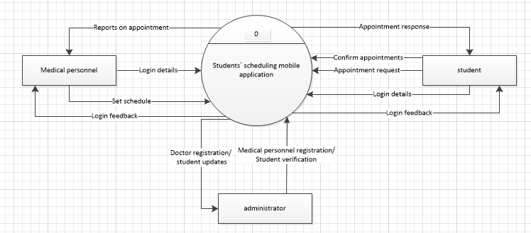

Figure showing SMA`s context Diagram

Key of symbols

 Process

 External entity

Data flow

Data store

**The level 1 DATA FLOW DIAGRAM**



Figure showing a data flow diagram for SMA

The DFD above shows the processes that take place in the Scheduling Mobile Application and the external entities that interact with the Application. The entities include students, medical staff and administrator who makes changes in the application.

The patient’s registration details are captured at registration and he or she is provided with login details after registration. The patient uses the login details to access the application services but before accessing these services, the patient must be authenticated. The patient views the medical staffs with their corresponding schedules for appointment. The patient uses these schedules to request for an appointment with a given medical staff. The student makes an appointment and receives an acknowledgement for the appointment.

The medical staff logs into the application. He or she sets schedules for appointments. He or she also views appointment requests made. So he or she prepares in time to attend to patients who he or she acknowledged for appointment.

The administrator registers and de register medical personnel into the application. He or she can also verify student registration by removing invalid students.

**Data dictionary of the DFD**

Table 1: **External entities of the DFD**

|  |  |
| --- | --- |
| Name | Description |
| Patient/ student | Represents a student who makes appointment to meet the doctor |
| Medical personnel | This represents the person who view and acknowledges appointments made by students so that he or she can attend to them at his or her set time |
| Administrator | This represents staff that have access to the system’s database to make necessary changes |

Table showing external entities of the DFD

Table 2: **Process of the DFD**

|  |  |
| --- | --- |
| Process name | Description |
| Authentication | This process helps to check if people accessing the system are authorized |
| Making appointment | This process shows how students make appointments and how medical personnel view the appointments |
| Registration | This one helps students register with the hospital plus the registration of medical personnel by the administrator |
| Updating or viewing schedules | This helps doctors update their schedules at the hospital and also approve or deny student requests. |

Table showing the processes of the DFD

Table 3: **Data stores in the DFD**

|  |  |
| --- | --- |
| Name | Description |
| Schedule records | Stores updates about schedules information |
| Authentication records | This stores authentication details submitted by users |
| Appointment records | This particular data store keeps appointment details submitted by medical personnel which are then viewed by doctors for approval |

Table showing the data stores in the DFD

**4.4.3 Architecture design of the system**

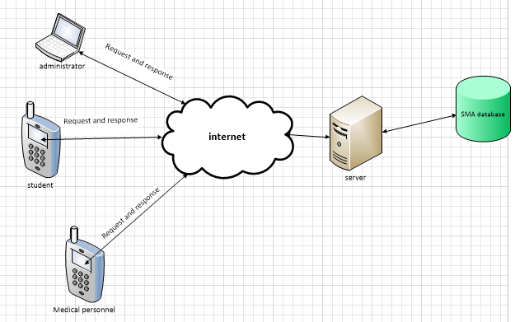

Figure showing the architecture design of the system

**4.4.4 Use case diagram**



Figure showing the use case diagram for SMA

**F**rom figure above, the only role of the administrator is to verify students’ registration, register and de register medical personnel. The student can make an appointment with a given medical personnel and wait for verification. The doctor can view the appointment and schedule time for the student when he or she is available. Finally the student can register on the system.

**User Requirements**

**a) Actor**: student

**Input**: log in credentials, registers at the hospital, make appointment with a medical personnel.

**Output**: successful login, successfully registered at the hospital, appointment sent.

**Precondition**: User has to be registered and using a smart phone connected to internet.

**Flow of Events**

a) Launches application

b) Register to access the application

c) Choose service and make appointment with a given personnel for that service.

d) Logs out on successful operations.

**Alternative flow of events**

a) Launches application

b) Login to access the application

c) Choose service and make appointment with a given personnel for that service.

d) Logs out on successful operations

**Alternative flow of events**

In case of invalid log in credentials, the student can’t access the application.

The information entered in the application won’t be saved to the database in case of a missing field or miss entered field.

**b) Actor**: Medical personnel

**Input**: log in credentials, set time for appointment with a student.

**Output**: successful login, appointment set successfully.

**Precondition**: staff has to be registered by the administrator and using a smart phone connected to the internet.

**Flow of Events**

a) Launches the SMA application

b) Logins to access the application

c) Sets time and date when he or she is available to meet a student.

d) Logs out on successful operations.

**Alternative Flow of Events**

In case of invalid log in credentials, the hospital personnel can’t access the application.

**The table below shows description of symbols in the use case diagram**

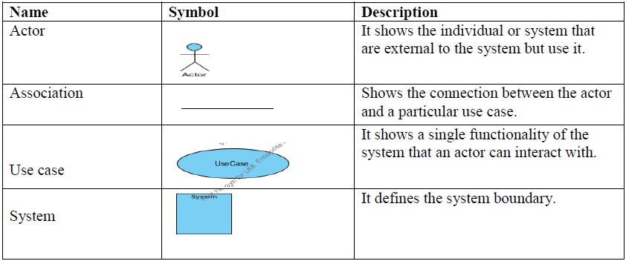

Table showing description of symbols in the use case diagram

**4.5 DATA MODELLING**

This is the analysis f data objects that are used in the business or other contexts and identification of relationships among these data objects.

**4.5.1 Conceptual data model**

Identification of entities and their attributes

|  |  |  |
| --- | --- | --- |
| Entity name | Description | Attributes |
| Medical personnel | Details of a given medical personnel who accepts or denies student appointment request | Medical personnel id, username, password, service provided |
| Student | A person who makes appointments with any medical personnel | Student number, Registration number, Course, telephone number, email, sex and name |
| Administrator | He is responsible for ensuring the right operation of the application through registering doctors and verify student registration | Username and password |
| Appointment | This is an activity of requesting to meet with some one | Appointment id, time, date and description/ reason |

Table showing the entities, descriptions and attributes of the ERD for SMA

**4.5.2 Modeling relationships between entities**



Figure showing the administrator-student relationship

An administrator verifies one or more students and a student can be verified by one administrator. Hence the cardinality is one to many.



Figure showing the medical personnel-student relationship

A medical personnel attends to one or more students and one student can be attended to by one or more medical personnel.



Figure showing the administrator-medical relationship

An administrator registers one or more medical personnel and one medical personnel can be registered by one administrator.



Figure showing the student-appointment relationship

A student requests for one appointment with a medical personnel and an appointment is requested by one student.



Figure showing the medical personnel-appointment relationship

A medical personnel sets one or many appointment and an appointment is set by one medical personnel.

**4.5.3 Entity relationship diagram for our developed Scheduling Mobile Application**

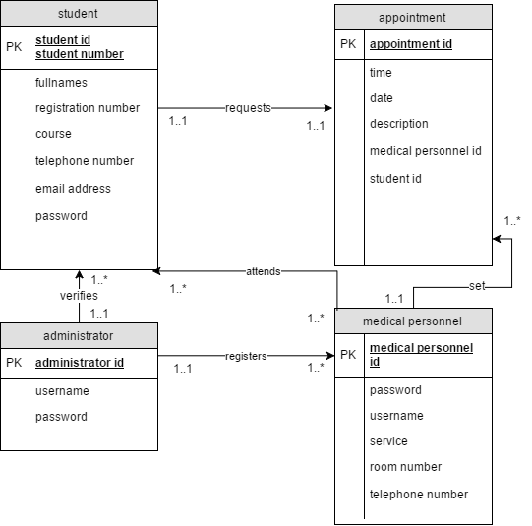

Figure showing the ERD for SMA

**4.6 Physical design**

After constructing the entity relations model for the system, we mapped this model onto a relational schema to design the structures of the relations to be constructed in the database implementation

**Administrator**

|  |  |  |
| --- | --- | --- |
| **Field name** | **Data type and size** | **Constraints** |
| Administrator id | Int(11) | Primary key and not null |
| Username | Varchar(50) | Not null |
| Password | Varchar(20) | Not null |

Table showing the description of the administrator entity

**Medical personnel**

|  |  |  |
| --- | --- | --- |
| **Field name** | **Data type and size** | **Constraints** |
| Medical personnel id | Int(11) | Primary key and not null |
| Username | Varchar(50) | Not null |
| Password | Varchar(20) | Not null |
| Service | Varchar(50) | Not null |
| Phone number | Int(10) | Not null |
| Room number | Varchar(10) | Not null |

Table showing the description of the medical personnel entity

**Appointment**

|  |  |  |
| --- | --- | --- |
| **Field name** | **Data type and size** | **Constraints** |
| appointment id | Int(11) | Primary key and not null |
| Time | Datetime | Not null |
| Date | Datetime | Not null |
| Description | Varchar(200) | Not null |
| Medical personnel id | Int(10) | Foreign key and not null references Medical personnel(Medical personnel id) |

Table showing the description of the appointment entity

**Student**

|  |  |  |
| --- | --- | --- |
| **Field name** | **Data type and size** | **Constraints** |
| Student no | Int(11) | Primary key and not null |
| Student id | Int(11) | Primary key and not null |
| Full names | Varchar(50) | Not null |
| Reg no | Varchar(20) | Not null |
| Course | Varchar(50) | Not null |
| Telephone number | Int(11) | Not null |
| Email address | Varchar(50) | Not null |
| Sex | Varchar(8) | Not null |

Table showing the description of the student entity

# 

# CHAPTER 5

**5.0 IMPLEMENTATION, TESTING AND VALIDATION**

**5.1 INTRODUCTION**

In his chapter we will describe the functionalities provided by the SMA using the screen shots we took and the findings of the research we carried out. The findings include results of every step we carried out. The steps taken in coming up with SMA include planning for the project, analysis of the already existing applications, requirements collection and developing the application with appropriate interfaces to meet the users’ needs. The developed prototype wentthrough several iterations and was finally validated. The application was implemented using Java for the interfaces, PHP and MySQL for the database.

**5.2 LITERATURE REVIEW RESULTS**

From the literature review, we found out that a scheduling mobile application should be an online application which can be accessed by any person in any place even in remote areas and at any time. It should have the ability to update schedules made by users (clients) so that the different users who are supposed to attend to the clients (those that request for appointments) get the information as soon as possible to avoid any inconveniences.

We found out that such an application can save the time spent by clients who lining up without knowing the schedules of the service providers who can leave any time there by leaving the clients unattended to.

We also found out that such application can reduce congestions at points of service delivery since only clients with appointments are most likely to turn up since they are sure of being attended to in environments where the clients are so many

**5.3 RESULTS OBTAINED FROM INTERVIEWS AND QUSETIONNAIRE**

From the 30 questionnaires we distributed, 23 of them were returned filled. We managed to interview 15 students and 5 medical staff members at Makerere university hospital. Although we were able to get the data that we needed, it was difficult because some staff members were not genuine and we also failed to get some staff members. The instruments were distributed to three groups of respondents and the results were as follows

**Administrator**

We found out the Makerere university hospital has been in existence for 37 years and has several doctors. The hospital offers services like immunization, x ray, ultra sound services, sexual and reproductive health services, routine medical examinations, drug dispensing and dental care. The hospital attends to a large number of students and people staying near it (local people). Registration is manual and it is done by secretary and students present their admission letters and identity cards at a fee of ten thousand.

**Doctors**

We found out that doctors prescribe medicine to students and note the next visitation day on medical forms. The doctors also said that they attend to a very big number of students every day since the university population is very big. Students come randomly to the hospital and over crowd the place and yet there are a limited number of doctors present which makes some students miss out on medical attention.

**Students**

Students said that they are not happy with the system at the hospital because they spend a lot of time in lines for like 2-3 hours waiting to be attended to and they sometimes miss out on medical attention. They also said they spend a lot of time looking for their manual files which the medical staff uses to attend to them. Also they spend so much time in registration since the system is manual and they have to line up for a good period of time. The files would have some mistakes that needed to be corrected for example the registration numbers, student numbers, etc.

**5.4 OBSERVATION RESULTS**

We spent some time observing the different activities that take place at the hospital. Students spent a lot of time in queues before being attended to by the medical staff most especially the doctors. Also students with appointments lined up with other students to get attended to by the different medical staff which was nagging.

**5.5 DATA ANALYSIS RESULTS**

From the data collected from the different individuals at the hospital, the study showed us the need for a mobile application which would help to eliminate all the delays and the errors made in the current system being used at the hospital. This would require all students to access the mobile application and make appointments with at any place in Uganda or outside Uganda for as long as they are computer literate. Their details would be captured and stored in the database and would be used by the hospital administrators concerned. After a successful login and making of an appointment, the concerned medical staff would accept the appointment and a notification would be sent back to the student for the appointment approval.

**5.6 IMPLEMENTATION RESULTS**

During the application implementation, we used different languages. These include java which we used to develop interfaces, PHP which we used to connect our application to the database, MySQL which we used to develop our database

**5.7 SYSTEM FUNCTIONALITY**

**Login page**

This is a login page for both the medical personnel and the students. This page consists of drop down where the user chooses whether he or she is a student or medical personnel so that he or she can login accordingly.

The student uses his or her student number and password to login into the application while the doctor uses his or her username and password to login. If a student is not registered yet, a registration button is available so that he or she can insert registration details and he is taken to the registration page.

After logging in, the student is taken to the services page where he or she can choose a specific service basing on his or her problem. The doctor is taken to the appointment page where he or she can view appointment requests sent by students.

**Student registration page**

The figure below shows the students registration page where the students are provided a form for them to fill in their details in order for them to request for appointments with the different university hospital medical personnel. The students must fill in their correct records without missing any fields in order for them to be registered.

**Services page**

The figure below shows the services page consisting of the different medical services provided by the university hospital which include immunization, x ray, ultra sound services, sexual and reproductive health services, routine medical examinations, drug dispensing and dental care where a student can choose any of them and he or she is taken to the page consisting of the different personnel for that service so that he or she can request for an appointment with any of them

**Student appointment pages**

The figure below show the appointment page where a student can request for an appointment with a medical personnel. It contains fields where the student can put the appointment details depending of his or her current situation which helps the doctor to know what he or she expects when a student arrives at the hospital. This contains the reason for requesting for an appointment. The other fields will automatically be filled with the student`s name and student`s number which will all be viewed by the specified medical personnel who the student is requesting to have an appointment with. After the student inserts the details, he or she then presses the “send” button which submits the appointment information into the database which will be available for that specific medical personnel.

# 

# Medical personnel appointment reply page

# This is where the medical personnel sets the time and date when he or she will be able to meet a given student who requested for an appointment with him or her. The page consists of a date and time picker which enables the medical personnel to easily choose the date and time. After he or she has chosen his or her appropriate time to meet the student, he or she then presses the reply button and the information is then stored in the medical personnel appointment table in the database.

# Medical personnel`s confirmed appointment page

# This is the page that consists of the medical personnel`s confirmed appointments with time and date when he or she will be meeting the different students.

**THE DESKTOP APPLICATION**

**Login page**

This is the page where the administrator logs into the desktop application. This leads the administrator to the home page where he can be able to remove wrong credentials of students (security wise) and also register medical personnel who will be attending to students.

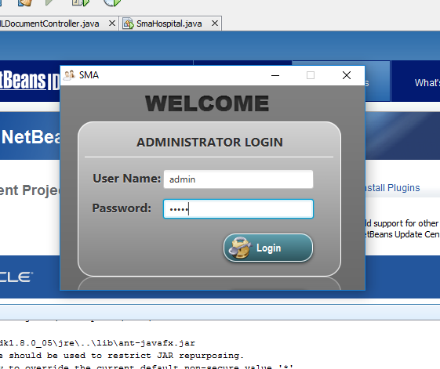

Figure showing the administrator`s login page so that they can access the desktop application

**Home page**

This is where the administrator actually registers medical personnel and also removes wrong student credentials. It has two tabs the student tab for students` wrong credential and the doctors` tab where the administrator can register the students.

Still on this page the administrator can edit the doctors` credentials and also remove doctors in cases where the doctor no longer works at the hospital.

# 

Figure showing the administrator page for registering and editing and deleting medical personnel details

# 

Figure showing the administrator page where he or she can delete student credentials when they are fake so the fake user cannot access the application

**Data flow diagram showing the flow of activities in the system and application**

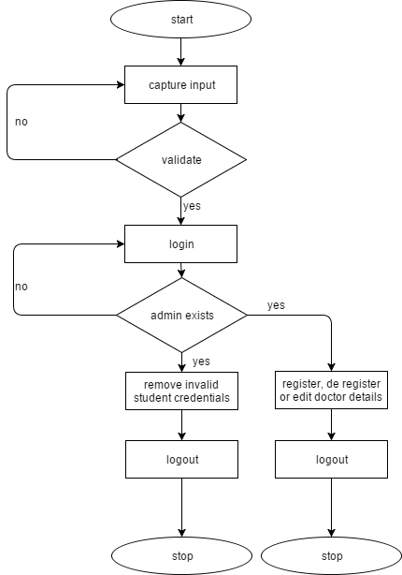

Figure showing a flow chart of how the administrator uses the system

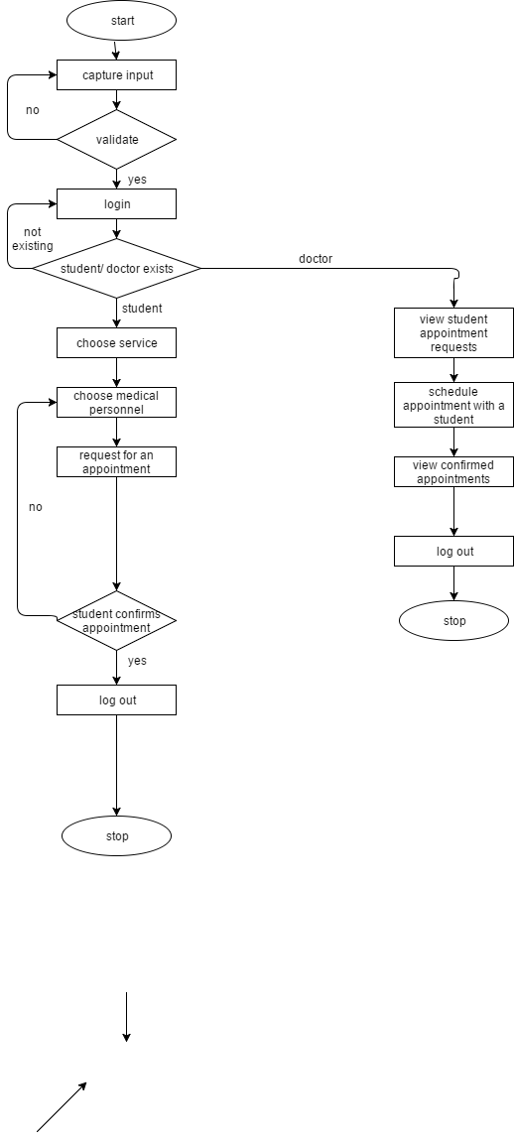

Figure showing a data flow diagram how the student or medical personnel would use the SMA application

**Testing and validation**

**Testing**

In this phase, we executed our application on an android mobile phone to see if the results are in conformance with the users` expectations and technical specification. Testing was intended for exposing the developed application to test inputs and observing its behavior to determine whether it is working as expected.

The information about student registration and appointments was processed fast enough without delays which reflected an efficient application. This enabled the doctor to receive that appointment request immediately it was sent by the student.

**Validation**

This refers to the process of ensuring that the data inserted into the application satisfies pre-determined formats or compiles with defined input criteria.

We allowed a small number of students to carry out the test of the application by feeding in their registration details and also requesting for an appointment with a given medical personnel. One of us acted as the doctor and was able to set the time and date when to meet the student. after the student confirmed the appointment, the details were sent the doctor`s confirmed appointment page. This enabled us to know whether the inserted information is the right information basing on the university`s required information. This also enabled us to know whether the application is user friendly and satisfies the user requirements depending on the users` comments.

During the application validation and testing, we found out that it meets the user`s needs and requirements. The application also provides security to students’ appointment information in that only the intended medical personnel can view this information. The medical personnel and the students have to first login to be authenticated to use the mobile application. A student has to first be registered first to be able to request for appointments with the different medical staff. If a person uses another student`s credentials to register with the application, the administrator can be informed and he or she can be able to delete the fake account and allow the eligible student to register.

The administrator can also delete or edit a given medical personnel`s account depending on the current situation for example when the medical personnel leaves the hospital.

# CHAPTER SIX

**6.0 INTRODUCTION**

This chapter presents the summary of the study findings; the conclusion arrived at and suggests areas that need more research to be carried out.

**6.1 CONCLUSION**

The stated objectives and design of SCHEDULING MOBILE APPLICATION were achieved to largely reflect the stipulations of the Makerere University Hospital management commitment. In the broadest terms, the SCHEDULING MOBILE APPLICATION goals and design are responsive to the call at the Makerere University Hospital to easy to access of medical services by the patients (students) and also to manage appointments efficiently since from the interviews we carried out, students were complaining of long lines in front of medical staff offices and in corridors. Sometimes students would not be attended to past working ours

This work is found rewarding as it enabled us researchers and developers to directly apply theory obtained from the lectures to real practical work. Course units like Data Structures and Algorithms, Database Management Systems, Research Methodology, Android development and Distributed Systems Development covered within the Bachelor of Science in Computer Science course have been largely applied in this project. During system implementation, the project enabled the scholars to learn more about the used programming tools like Java method invocations, and master their skills in creating and managing database using MySQL. We are now exposed to real life challenges of application development. Lastly, we have learnt to appreciate research journals, projects done by the previous students at COCIS, those posted on internet from different formulas and documentations of other scholars because they have helped us in coming up with the project report.

**6.3 LIMITATIONS**

It was difficult to decide which technology to use as some of the development platforms posed challenges to the designers. Below are some of the limitations

1. Insufficient resources to carry out some of the project activities in addition to limited access to college resources such as Internet, power some time and the Library.

2. It was difficult to collect data at Makerere University Hospital since some of the top administrators were most of the times busy, on and off in their respective offices.

3. Short duration for project completion. It was challenging to juggle between lectures and project activities.

**6.4 SUMMARY**

The Application is a Student Scheduling Application which is android based that keeps track of student’s information as they register with it eliminating the manual student’s registration. With the advancement of technology in Uganda and the world at large, while using this application students can request for an appointment with the medical staff at the university hospital who can in turn set time and date which is convenient to them. Students also know when the different medical staffs of different departments are available at the hospital so that they go to the hospital knowing that they are going to get the services they want.

The project successfully achieved the objectives identified in chapter one. A scheduling Application has been designed and implemented as per the requirements and expectations of the users (student and staff).

**6.5 Recommendations**

Although the project was investigated, analyzed, designed, developed and implemented, a number of details were not covered as to utilize the fullest capacity of the application. It is therefore recommended that further study is under taken to improve the following

* Makerere University Hospital should provide a server to run the desktop application and database. We recommend Makerere University Hospital to implement the application as it is applicable to its situation since it was developed using its details and requirements. This will reduce the stressing factors and time wasted that were observed and also improve the record keeping problems recognized with the traditional system.
* The hospital should think of using an online scheduling mobile application.
* Full time applications to remind students to honor their appointments. An automatic SMS reminder should be sent for each appointment an hour before appointment time.
* The application should consider all hospital clients which include lecturers and residents near the hospital without considering only students.
* A student should be able to cancel an appointment in case he or she is too busy to honor it.

# References

1. Mukasa, N. (2017, january 27). *Uganda Healthcare System Profile*. Retrieved from ResearchGate: <https://www.researchgate.net/publication/264271298_Uganda_Healthcare_system_profile_Background_Organization_Polices_and_Challenges>

*wikipedia*. (2016, june 2). Retrieved from wikipedia: <https://en.wikipedia.org/wiki/Makerere_University_Hospital#References>

2. Ndyabahika, D. (2016, october 10). *the state of makerere university hospital*. Retrieved from UgandaRoadNetwork: <https://ugandaradionetwork.com/story/the-state-of-makerere-university-hospital>

3. MakerereUniversity. (2017, january 3). *University hospital*. Retrieved from Makerere University: <https://www.mak.ac.ug/university-services/university-hospital>

4. wikipedia. (2017, january 14). *Scheduling_(production_processes)*. Retrieved from Wikipedia: <https://en.wikipedia.org/wiki/Scheduling_(production_processes)>

Margaret, R. (2013, December). *mobile-app*. Retrieved from techtarget: <http://whatis.techtarget.com/definition/mobile-app>

5. U.S.DepartmentofVeteransAffairs. (2017, february 24). *veteran-appointment-request*. Retrieved from U.S. Department of Veterans Affairs: <https://mobile.va.gov/app/veteran-appointment-request>

6. Jackie, N. D. (2006). *A web based hospital service system.* kampala: Namugalu Diaana Jakie.

Spectrosoft. (2010, june 30). *appointmentsoftwareappointmentspro*. Retrieved from Spectraform: <http://Spectrasoft.compractice-management-software/medical-scheduling-software/patient-scheduling/appointment-software-appointmentspro>

7. Neusofttechonologies. (2011, july 01). *medicalschedulingsoftware*. Retrieved from capterra: <http://www.capterra.com/medical-scheduling-software>

8. Nikhil. (2010, November 21). *interview-method-of-data-collection*. Retrieved from mass-communication-tutorials: <http://mass-communication-tutorials.blogspot.ug/2010/11/interview-method-of-data-collection.html>

9. McLeod. (2017, january 27). *questionaires*. Retrieved from Simplipsychology: <http://www.simplypsychology.org/questionaires.html>

10. Slater. (2003, 27 2). *kbmanage*. Retrieved from brianstorming: <https://www.kbmanage.com/concept/brainstorming>

*11. medical scheduling software*. (2011, july 01). Retrieved from capterra: <http://www.capterra.com/medical-scheduling-software>

# APPENDICES

**INTERVIEW**

**Interview guide**

We are undergraduate students from Makerere University from the department of computer science conducting a survey on understanding the process of appointment at Makerere University Hospital and our main objective is to develop a scheduling mobile application. Therefore we kindly request you to respond honestly to the following questions which are divided into two questions A and B in order to help us through the process of development.

The information provided will be kept with great confidentiality by our team and your participation will be highly appreciated.

**SECTION A: THE BACKGROUND AND REGISTRATION.**

**Background**

**ADMINISTRATOR**

1. How long has this hospital been in operation?

……………………………………………………………..

1. What is the capacity of the hospital?

……………………………………………………………..

1. What services does the hospital provide?

……………………………………………………………..

1. How many doctors do you have at the hospital?

……………………………………………………………..

1. What could be the average number of students handled in a year?

……………………………………………………………..

1. Do you have a registration office?

Yes No

If yes continue to Q8 and if not answer Q7

1. How is registration handled?

………………………………………………………………

1. Who is supposed to register?

………………………………………………………………

1. What are the requirements for one to be registered?

………………………………………………………………

1. How many students are registered monthly?

……………………………………………………………….

1. Which challenges are faced in registering (patients) students?

……………………………………………………………….

**PATIENTS**

1. At what time did you arrive at the hospital?

……………………………………………………………….

1. How long did take you to be registered?

……………………………………………………………….

1. How easy was it access the doctor after registering?

…………………………………………………………….....

1. For how long did it take you do consultation with the doctor?

……………………………………………………………….

1. Is the process that you went through that comfortable to you?

**DOCTOR**

1. How do you make appointments with students?

………………………………………………………………

1. How many patients do you work on per a day?

……………………………………………………………….

1. What challenges do you face in handling appointments?

………………………………………………………………..

1. How would you improve/modify the current appointment process?

………………………………………………………………..

**QUESTIONNAIRE**

We are undergraduate students from Makerere University from the department of computer science conducting a survey on understanding the process of appointment at Makerere University Hospital and our main objective is to develop a scheduling mobile application. Therefore we kindly request you to respond honestly to the following questions which are divided into two questions A and B in order to help us through the process of development.

The information provided will be kept with great confidentiality by our team and your participation will be highly appreciated.

**Background and registration**

**Background**

1. How long has this hospital been in experience?

* 10 years
* 20 years
* 25 years
* Others specify…………………………………………………………..

1. What services does the hospital provide?

…………………………………………………………………………..

1. How many doctors do you have at the hospital?

* 2
* 3
* 4
* 5
* Others specify if any……………………………………………………..

1. What is the average number of patients (students) you handle in a year?

* 1000
* <1000
* >1000
* Other specify……………………………………………………………….

1. What is the capacity of your hospital?

……………………………………………………………………………………….

**Registration**

1. Do you have a registration table?

Yes No

If **Yes** continue to Q3 and if **No** answer Q2

1. How do you handle registration?

…………………………………………………………………………

…………………………………………………………………………

………………………………………………………………………….

1. Who is legible to be registered?

………………………………………………………………………….

1. What are the requirements to be registered?

* Identity card
* Admission letter
* Registration fee
* Others specify…………………………………………………….

1. How many students do you register in a week?

* 100
* 200
* 300
* Others specify………………………………………………………….

1. What challenges do you face registering students?

………………………………………………………………………………..

………………………………………………………………………………..

………………………………………………………………………………..

………………………………………………………………………………..

1. After registration what follows?

………………………………………………………………………………..

………………………………………………………………………………..

………………………………………………………………………………..

**Appointments**

**Doctor**

1. How do you make appointments with your patients?

* Phone calls
* Patient cards
* Others specify………………………………………………………..

1. How many patients do you treat a day?

* 10
* 15
* 20
* Others (specify)……………………………………………………..

1. What challenges do you face while handling appointments?

………………………………………………………………………………

1. How would you wish to modify the appointment process?

………………………………………………………………………………

………………………………………………………………………………

………………………………………………………………………………

**OBSERVATION FORM**

1. The time the patient arrived at the hospital?
2. How long it took the patient to register?
3. How registration is done?
4. How long it took the patient to do consultations?
5. How long the patient spent at the hospital?
6. How is it is to access it he doctor after registration?
7. How are appointments made?
8. How appointment patients are handled?

**WORK PLAN FOR OUR PROJECT**

|  |  |  |  |
| --- | --- | --- | --- |
| PROJECT WORK PLAN | | | |
| TASKS | START DATE | DURATION(DAYS) | END DATE |
| Idea generation | 9th oct 2016 | 3 days | 11th oct 2016 |
| Project Definition | 12th oct 2016 | 1 week | 18th oct 2016 |
| Concept paper writing | 19th oct 2016 | 2 weeks | 2nd nov 2016 |
| Requirements collection | 2nd jan 2017 | 1 week | 9th jan 2017 |
| Proposal writing | 10th jan 2017 | 2 weeks and 2 days | 26th jan 2017 |
| Proposal presentation | 27th jan 2017 | 1 day | 27th jan 2017 |
| **Coding** |  |  |  |
| Phase 1 | 1th mar 2017 | 2 weeks and 3 days | 17th mar 2017 |
| Phase 2 | 18th mar 2017 | 2 weeks and 3 days | 3rd april 2017 |
| Additional features | 4th april 2017 | 1 week | 10th april 2017 |
| **Testing** |  |  |  |
| Phase 1 Testing | 11th april 2017 | 1 week | 17th april 2017 |
| Phase 2 Testing | 18th april 2017 | 1 week | 24th april 2017 |
| Documentation | 25th april 2017 | 2 week | 8th may 2017 |
| Presentation | 15th may 2017 | 5 days | 20th may 2017 |
|  |  |  |  |

**BUDGET FOR OUR PROJECT**

|  |  |  |
| --- | --- | --- |
| **PROJECT BUDGET** | | |
| **ITEMS** | **RATE** | **AMOUNT IN SHELLINGS** |
| **Equipment** |  |  |
| Stationaries |  | 1,620,000 |
| PC Computer | 1,200,000 each | 4,800,000 |
| Printer | 1,000,000 | 1,000,000 |
| Phones | 500,000 each | 2,000,000 |
| Server | 2,000,000 | 2,000,000 |
| **Miscellaneous** |  |  |
| Operation, Maintenance, Repair of equipment |  | 1,500,000 |
| Communications/ airtime |  | 200,000 |
| **Website hosting** | 500000 per year | 500,000 |
| **In-service Training** |  |  |
| Rent of the workshop facilities |  | 1,000,000 |
| Refreshments |  | 150,000 |
| Transportation for the workshop |  | 300,000 |
| **Grand Total** |  | **15,070,000** |